Mauritania

## GNI per capita and development level

The data set shows the GNI per capita and development level of the country each year.

## # A tibble: 19 x 5  
## country iso3c date GNIperCapita devCategory   
## <chr> <chr> <dbl> <dbl> <chr>   
## 1 Mauritania MRT 1996 1680. Lower Middle Income  
## 2 Mauritania MRT 1998 1578. Lower Middle Income  
## 3 Mauritania MRT 2000 1486. Lower Middle Income  
## 4 Mauritania MRT 2002 1444. Lower Middle Income  
## 5 Mauritania MRT 2003 1499. Lower Middle Income  
## 6 Mauritania MRT 2004 1525. Lower Middle Income  
## 7 Mauritania MRT 2005 1602. Lower Middle Income  
## 8 Mauritania MRT 2006 1771. Lower Middle Income  
## 9 Mauritania MRT 2007 1695. Lower Middle Income  
## 10 Mauritania MRT 2008 1657. Lower Middle Income  
## 11 Mauritania MRT 2009 1636. Lower Middle Income  
## 12 Mauritania MRT 2010 1591. Lower Middle Income  
## 13 Mauritania MRT 2011 1586. Lower Middle Income  
## 14 Mauritania MRT 2012 1600. Lower Middle Income  
## 15 Mauritania MRT 2013 1622. Lower Middle Income  
## 16 Mauritania MRT 2014 1630. Lower Middle Income  
## 17 Mauritania MRT 2015 1687. Lower Middle Income  
## 18 Mauritania MRT 2016 1677. Lower Middle Income  
## 19 Mauritania MRT 2017 1694. Lower Middle Income

## GDP growth and economic growth classification

The data set shows the GDP growth and the ecomic growth classification of the country each year.

## # A tibble: 19 x 5  
## country iso3c date GDPannualGrowthRate GDPgrowthCategory4  
## <chr> <chr> <dbl> <dbl> <fct>   
## 1 Mauritania MRT 1996 5.82 fast growth   
## 2 Mauritania MRT 1998 2.78 moderate growth   
## 3 Mauritania MRT 2000 -3.92 negative grwoth   
## 4 Mauritania MRT 2002 1.38 slow growth   
## 5 Mauritania MRT 2003 6.93 fast growth   
## 6 Mauritania MRT 2004 4.73 moderate growth   
## 7 Mauritania MRT 2005 8.57 fast growth   
## 8 Mauritania MRT 2006 18.3 fast growth   
## 9 Mauritania MRT 2007 -1.97 negative grwoth   
## 10 Mauritania MRT 2008 -0.331 negative grwoth   
## 11 Mauritania MRT 2009 0.0979 slow growth   
## 12 Mauritania MRT 2010 2.62 moderate growth   
## 13 Mauritania MRT 2011 4.17 moderate growth   
## 14 Mauritania MRT 2012 4.47 moderate growth   
## 15 Mauritania MRT 2013 4.15 moderate growth   
## 16 Mauritania MRT 2014 4.27 moderate growth   
## 17 Mauritania MRT 2015 5.38 moderate growth   
## 18 Mauritania MRT 2016 1.26 slow growth   
## 19 Mauritania MRT 2017 3.50 moderate growth

## Development trend

The plot shows the development trend of the country.

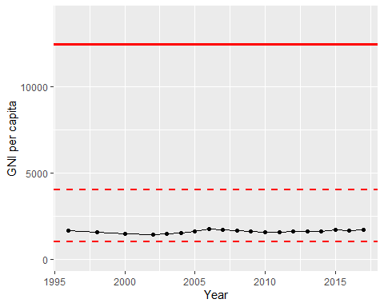

GNI Per Capita Trend